[Home](https://danielmiessler.com/) » [Study](https://danielmiessler.com/study/) » The Difference Between Fedora, Redhat, and CentOS

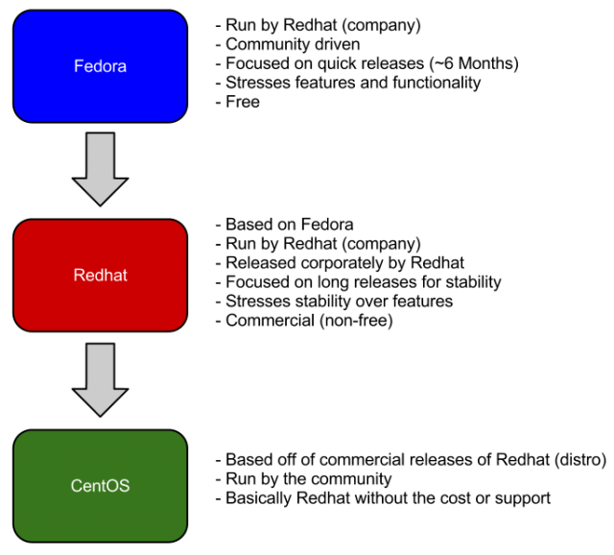

[ NOTE: For more primers like this, check out my [tutorial series](https://danielmiessler.com/study/). ]

People are often confused by the relationship between Fedora, Redhat, and CentOS. Are they the same company? Is one another version of the other? Which one is more up to date? Etc.

They go in order starting from the top, as shown in the graphic above.

1. **Fedora** is the main project, and it’s a communitity-based, free distro focused on quick releases of new features and functionality.
2. **Redhat** is the corporate version based on the progress of that project, and it has slower releases, comes with support, and isn’t free.
3. **CentOS** is basically the community version of Redhat. So it’s pretty much identical, but it is free and support comes from the community as opposed to Redhat itself.